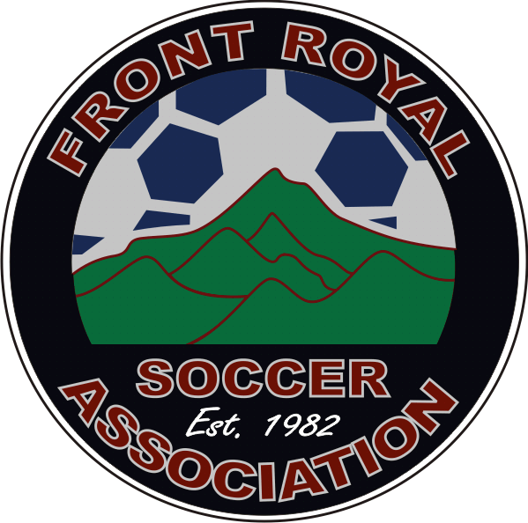
FRONT ROYAL SOCCER ASSOCIATON

MARCH NEWS

www.frontroyalsoccer.com Hotline: 540-635-2966

The FRSA board would like to welcome you to the Spring 2012 season! Opening Day is March 31st!
Welcome new board members:
Jim Blakely – Kiddie Kickers Commissioner
Chad Franklin – U8 Co-Commissioner
Kenesa Haffer – U10 Girls Commissioner
Jaime Moore – U10 Boys Commissioner
Denise Clatterbuck – Equipment Manager

FRSA Player Development Training – Skyline SoccerPlex
Wednesdays – April 18th – May 9th – 6:00-7:30 pm
Don’t forget to join us for this valuable training. All training sessions will be conducted by area high school coaches and players. Training will focus on developing the foundation skills of soccer: dribbling, ball control, kicking, shooting and passing, and goalie training. Coaches are highly encouraged to attend this training with their teams.

Wednesday, April 11th – Warren County High School
Warren County Wildcats vs Skyline Hawks
5:00 PM – Girls Varsity
7:00 PM – Boys Varsity

Friday, April 27th – Skyline High School
Skyline Hawks vs Warren County Wildcats
5:00 PM – Girls Varsity
7:00 PM – Boys Varsity

Players who wear their FRSA jersey will receive FREE admission to these games! This is a great opportunity to watch soccer played at a higher level and to support your local high school soccer teams! Players must be accompanied by a parent or other adult chaperone.

FRSA Night at RFK Stadium – Saturday, May 19th – 7:30 PM – DC United v Toronto FC

All ticket orders must be pre-paid in full by Saturday, April 21st. Tickets can be ordered at the concession stand.
FRSA has purchased a group of 50 tickets for this game. Don’t miss this great opportunity for your young soccer player to watch a professional soccer game. Players who wear their FRSA jersey will get to participate in pre-game festivities!
These experiences include an up-close view of pre-game warm ups from field level, and recognition on the stadium PA system and Jumbotron!

Friendly Reminders! Please remember, FRSA does not allow the use of tobacco products around our players, around the fields, or on or near the playground. There is a designated smoking area behind the Concession Stand.
FRSA is not responsible for children playing on the playground or at the Skatepark. Please be aware of where your children are at all times. Thank you!

Please help us to help the environment and to keep our beautiful Skyline SoccerPlex clean!

There are trash and recycle bins located throughout the SoccerPlex. Please empty bottles and cans and place them in recycling bins, and place all trash in trash cans. Together we can all make a difference!


HELP US AS WE GROW!!!
Need: Additional or improved practice and game fields, goals, and nets

What you can do to help – Front Royal Soccer Association has two great ways for you to help us, without selling anything!

MARTIN’S CASH FOR CAUSES GIFTCARDS – Martin’s sells giftcards to FRSA at a discounted price. FRSA members purchase the cards at face value, and FRSA keeps the difference. Members use the cards to pay for their regular household groceries.

SCRIP GIFT CARD FUNDRAISING – Does your family like to dine out? You can raise money for FRSA just by visiting your favorite restaurants! FRSA will have select gift cards available for immediate purchase at the Concession Stand. Restaurants include TGI Fridays, Cracker Barrel, Applebees, Starbucks, and Outback Steakhouse.
US SOCCER FOUNDATION’S PASSBACK PROGRAM


Through the Foundation's Passback Program, new and gently used soccer gear is collected by organizations, teams, clubs and individuals and is redistributed across the globe to help underserved communities play the Beautiful Game. Soccer is a unifying force that brings together people of all ethnicities and has the power to open doors, hearts and minds of those who play.

As part of her Girl Scout Silver Medal project, Krystina McCullough will be collecting new and gently used soccer jerseys, shorts, cleats, shin guards, and balls. FRSA will have a collection box at the Concession Stand throughout the Spring 2012 season.

CHALLENGER BRITISH SOCCER CAMP – August 13th-17th
Location: 15th Street Field (Former Middle School)

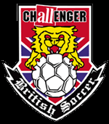
British Soccer Camps provide players of all ages and abilities with the rare opportunity to receive high-level soccer coaching from a team of international experts. Each day includes individual foot skills, technical drills, tactical practices, small-sided games, coached scrimmages, and a daily tournament. Equally important, the Challenger coaching staff provides your child with lessons in respect, responsibility, integrity, sportsmanship and leadership. Camp programs include a free ball and shirt and a free British Soccer jersey for online registrations completed by July 1st. Full and half day camps are available. Please visit the Summer Camp page at www.frontroyalsoccer.com to register or for further information.
Register in person during our First Annual FRSA Soccer Showcase on June 9th!

MARK YOUR CALENDARS!
Saturday, April 7th – No Games – Easter Weekend
Wednesday, April 11th – Warren County High School – Wildcats v Hawks, 5:00 – Girls, 7:00 – Boys
Wednesdays, April 18th – May 9th – 6:00-7:30 – FRSA Player Development Training
Saturday, April 21st - DC United Ticket Orders and Payment Due
Friday, April 27th – Skyline High School – Hawks v Wildcats, 5:00 – Girls, 7:00 - Boys
Saturday, May 26th – No Games – Memorial Weekend (Weather Make-up)
Saturday, June 9th – 1st Annual FRSA Soccer Showcase – Board Elections

INCLEMENT WEATHER: FRSA will hold games whenever it is safely possible to do so. Games may be played in extreme heat or cold conditions, as well as in light rain, snow, or windy weather. The decision to cancel a game that is in progress is the responsibility of the Center Referee. In the event of thunder and/or lightning, all games or activities shall be stopped and fields cleared immediately. In the event a game is suspended because of weather conditions, if a game reaches halftime it is considered an official match. Otherwise the game will be rescheduled by FRSA if possible.
Please check www.frontroyalsoccer.com or call 540-635-2966 for cancellation information. FRSA now has a Facebook page! Like us on Facebook at the bottom of our homepage and stay up to date on what’s happening with FRSA!

1ST ANNUAL FRSA SOCCER SHOWCASE – SATURDAY, JUNE 9TH
FRSA is growing so much that we can no longer manage Rainbow Games as we have in the past. Instead, we plan to celebrate soccer and the end of our season in a new, exciting way, with FRSA Soccer Showcase! This is a work in progress, and we have formed a committee to develop this event. Committee members include Connie Dueweke, Amanda Slate, Monica Blake, Lissa Blakely, and Kenesa Haffer. If you would like to volunteer for the planning stages, and/or for the event, please contact any member of the committee. We appreciate your support and understanding as we grow and change!

FRSA HOTLINE – 540-635-2966 – A board member will have the FRSA cell phone with them at all times during games. If you see anything that needs to be reported to the board, please call! A board member or a field marshal will come to investigate. Field marshals are certified referees over the age of 21 and will be wearing red referee shirts.

Front Royal Soccer Association would like to thank the
following sponsors for their generous contributions!
Shenandoah Valley Orthodontics Tropical Smoothie Café  Jalisco  Little Sheep Preschool MARTINS Breaktime Billiards  Kiwanis Club of Front Royal Warren Memorial Hospital | Valley Urgent Care  Front Royal Rotary Club Jennerations Hair Studio Ferguson  Century 21 Campbell Realty Lester & Mowery’s Pharmacy Edward Jones  RPS Composites | Priest Construction Salon La Petite  Royal Family Bowling  Royal Cinemas Greenway Engineering  Dr. Broadhead and Dr. Heard  DC United

